CTAI Team Project: Energy Consumption Analysis

Introduction: Project Context & Goals

This project is based on the proposal from our client, Jeroen De Baets (Energy Lab).

The Problem (What): Households and small companies are consuming more energy due to electric cars, heat pumps, and batteries. The classic methods to analyze this consumption are expensive and require complex hardware.

The Objective (Goal): We will investigate how AI can analyze this energy consumption in a smarter and cheaper way, using existing measurement data from InfluxDB.
Our specific goal is to develop a proof of concept that automatically learns which appliances are active based only on the building's total energy measurement. The system will learn to recognize consumption patterns to predict how much each appliance is using, identify large consumers, and create an interactive dashboard for the user.

The Data (Data): We will use the provided 1-year JVR dataset from InfluxDB, with measurements every 15 minutes. The dataset includes both individual appliance readings (e.g., Dishwasher, Heat Pump) and total building consumption (e.g., Building - consumption - Total - Smappee), which will be used to train our AI. Additionally, we have some extra data with a 1-second resolution for a few months, which we may explore later if needed.

Team Role Distribution

Our team consists of 3 students and will adopt the Agile Scrum methodology. The roles are distributed as follows to cover all technical and project management needs:

AI & Data Specialist (Scrum Master): Tommaso Pioda
Responsibilities: Leads research on AI models (seq2point, LSTM, Transformer), performs data analysis, and trains the deep learning models. Also facilitates the Scrum process, manages Trello

Backend & Data Engineer: Mirko Keller
Responsibilities: Develops Python scripts for data cleaning and pivoting (preprocessing). Implements the backend that connects the trained model to the frontend using Flask, and manages the project’s GitHub repository.

Frontend & UX Developer (Product Owner): Rodrigo Sousa
Responsibilities: Acts as the main liaison with the client (Jeroen De Baets) to ensure the solution meets the goals. Develops the interactive dashboard to visualize energy trends, peak load, and consumption, and public relationships.

Description of the Research for the Project

Context and Objectives
This project is based on a well-known problem in energy research called Non-Intrusive Load Monitoring (NILM). NILM aims to estimate how much energy each appliance in a building consumes by analyzing only the total power recorded at the main meter.
The goal of this project is to build a system that can automatically recognize which appliances are active and estimate their energy usage using only aggregated smart-meter data.
The project also aims to develop an interactive dashboard that displays energy use per appliance, peak demand, and trends, while providing practical insights on how to improve both the AI models and the dataset.

Application and Use
It can help users understand where energy is spent and how to reduce it. In future versions, higher-frequency data and attention-based models can improve precision and long-term prediction.

Research Background
Over the years, many studies have explored how to solve this problem using machine learning and deep learning methods, mainly:

- Seq2Point Convolutional Neural Networks (CNNs): These models use a short window of total energy data to predict the power of one appliance at a specific moment. Research shows that CNN-based Seq2Point models work very well on low-frequency datasets (10–15 minutes) and are fast to train.

- Recurrent Models (LSTM, GRU): These models can capture time dependencies but train more slowly and was seen on some research that may perform worse than CNNs in NILM tasks.

- Attention and Transformer Models (e.g., Energformer, PatchTST): These architectures can capture complex and long-term dependencies between appliances, but they rely on high-frequency data (1–10 seconds) and require bigger computational resources.

CNN-based models are more efficient and stable for low-frequency smart meter data, while Transformers should perform better with higher-frequency data or when predicting multiple appliances simultaneously. CNNs struggle with simultaneous multi-appliance prediction because they focus on short local windows and cannot easily capture correlations between appliances.

Chosen Approach
Given the 15-minute interval data, the primary approach will be a Seq2Point CNN model, with GRU-based sequence models as an alternative. This approach can be trained on the existing 15-minute smart meter data, efficiently estimates which appliances are active and their energy consumption, and runs quickly on a single GPU.
Extra: Higher-frequency (1-second) data is available for some months. If the Seq2Point approach does not achieve satisfactory results, Transformer-based models may be explored to capture more detailed appliance patterns. The main limitation of the current dataset is that the low resolution may make rarely used devices harder to detect. Transformer models are unlikely to improve performance on low-frequency data but offer potential if higher-resolution data is used.

Technical Solution Architecture

This outlines the practical implementation of our "Chosen Approach," detailing the data flow from the database to the user's dashboard.

1. Data Pipeline & Preprocessing (Mirko, Tommaso)
Python scripts will connect to InfluxDB to extract, clean, and pre-process the 15-minute JVR dataset. The data will be transformed into the required aggregate (input) and appliance-specific (target) formats needed for model training.

2. AI Model Implementation (Tommaso)
We will implement the chosen Seq2Point CNN architecture. This model uses a "window" of aggregate consumption data to predict the specific consumption of one appliance at a time. Separate models will be trained for each key appliance (e.g., Dishwasher, Heat Pump).

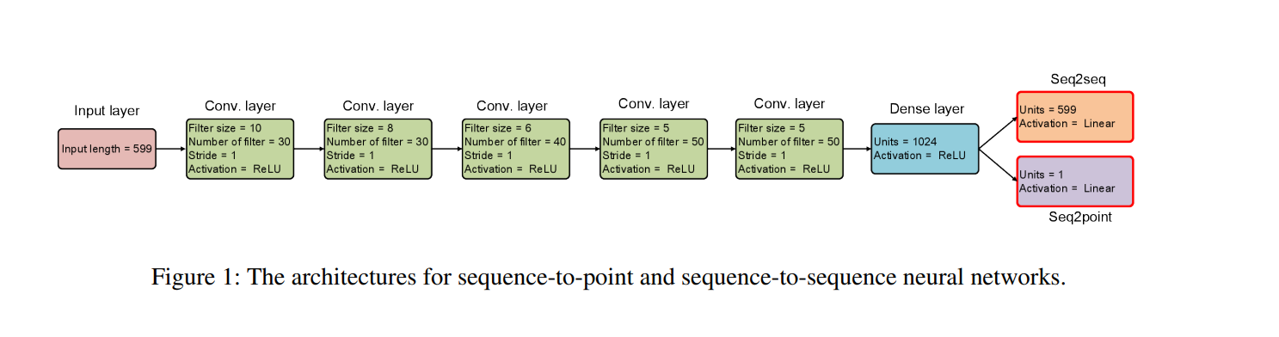

3. Backend API (Mirko)
A Flask-based backend will be implemented to serve the trained models and manage prediction requests. It will receive aggregated building consumption data, process it through the appropriate appliance models, and return structured results with the estimated energy consumption for each appliance. The backend will act as the connection between the AI models and the frontend dashboard, enabling real-time disaggregation and visualization of appliance-level energy use.

4. Frontend Dashboard Integration (Rodrigo)
The interactive dashboard will send the building's total consumption data to the Flask API. Upon receiving the JSON response, it will use visualization libraries to display the energy breakdown per appliance, peak loads, and other information that the user may request.

System Architecture

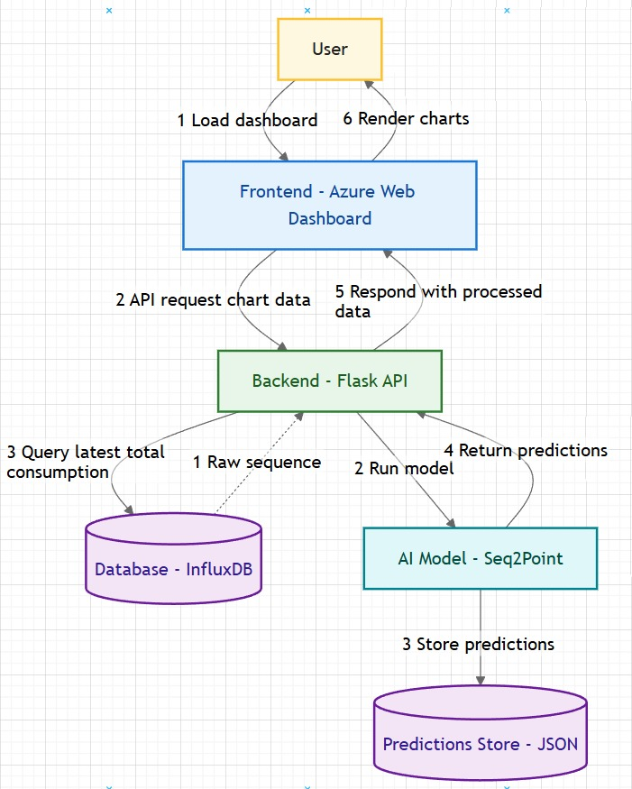

Client input or decisions
A point to clarify is the exact method of data access.
We must confirm whether we will have direct, "live" API access to the InfluxDB or if we will be working from a static data export (such as the provided JVR dataset in an Excel/CSV file).
Since the answer will have an impact on the initial design of our data pipeline and the overall system architecture.

Trello Link:
https://trello.com/b/bm1Qd3Wa/energyg1

Github Link:
https://github.com/Krim0k27/team_project

Sources:
https://arxiv.org/pdf/1612.09106

https://arxiv.org/pdf/2210.04176

https://towardsdatascience.com/sequence-to-point-neural-network-for-nilm-6719584fa21f/

https://pure.strath.ac.uk/ws/portalfiles/portal/100820681/Zhao_etal_AE_2020_Non_intrusive_load_disaggregation_solutions.pdf

https://www.eng.auburn.edu/~szm0001/papers/WangIoT22.pdf#:~:text=to%20the%20above%20problems%20,attention%20mechanism%20to%20capture%20the

https://homepages.inf.ed.ac.uk/csutton/publications/aaai18nilm.pdf#:~:text=paper%2C%20we%20propose%20sequence,we%20systematically%20show%20that%20thehttps
link.springer.com/article/10.1007/s10489025069214#:~:text=The%20application%20of%20transformers%20also,operational%20patterns%20and%20low% 20utilization

https://ecofactproject.eu/wpcontent/uploads/2023/04/Energformer__A_New_Transformer_Model_for_Energy_Disaggregation.pdf

https://www.researchgate.net/publication/387339384_Enhancing_Energy_Disaggregation_with_Attention-Based_Neural_Network

https://www.youtube.com/watch?v=vlTOYa4aU9g

https://ieeexplore.ieee.org/document/10020155

https://ieeexplore.ieee.org/document/9745140
Gemini and Chatgpt deep research

